First Order Derivative

Definition:
- The first derivative tells us about the direction the function is going. That is, it tells us if the function is increasing or decreasing.
- The first derivative can also be interpreted as the slope of the tangent line.

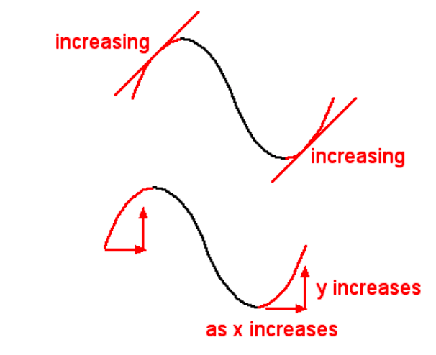

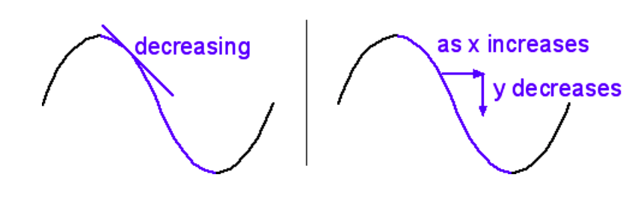

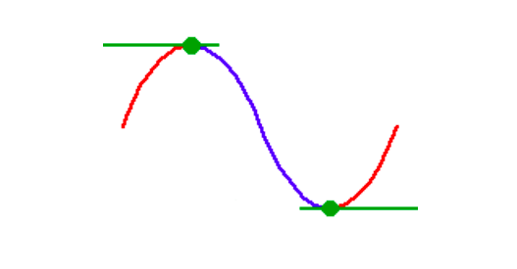

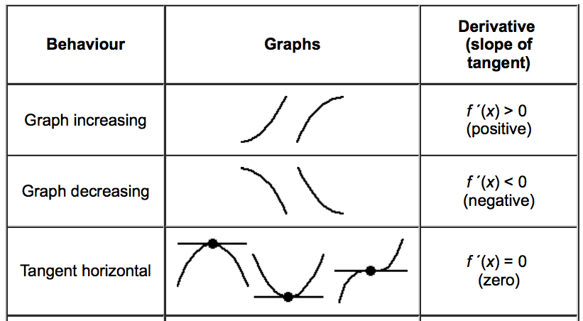

Definition:
- A critical number of a function is a number in the domain of f such that either f’(c)=0 or f’(c) does not exist.

Examples:
Find the Derivative for the following examples.
1. $f\left(x\right)=x^{4}-{3x}^{2}+2x-8$ 2. $f\left(x\right)= {6x}^{3}+{9x}^{2}-360x$

3. Find the critical number(s) for $f\left(x\right)=x^{2}-6x$.

Steps for Determining where f is increasing or decreasing:

- Find all critical number(s).
- Plot critical number(s) on a number line.
- Choose values to test regions on the number line around the critical number(s). Plug test values into f’ and record the sign.
- If the sign is positive, then f is increasing and if the sign is negative, then f is decreasing.

Example:
Find where the function, $f\left(x\right)=x^{2}-6x$ is increasing and decreasing.
Step 1: Critical number(s)

Step 2 and 3: Number line/Test Values

Step 4: Increasing and decreasing intervals

AN EASIER WAY…

- Go to Desmos.com
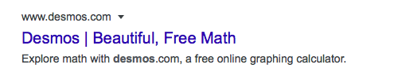

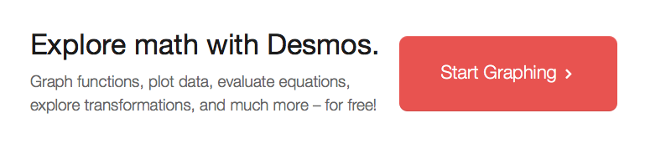
- Click on “Start Graphing”

- On the left hand side, begin typing in the function:
$f_{1}(x)=x^{2}-6x$. (To acquire the exponent, hit “shift, 6”. Make sure to move the cursor to the right so no other numbers are in the exponent.)
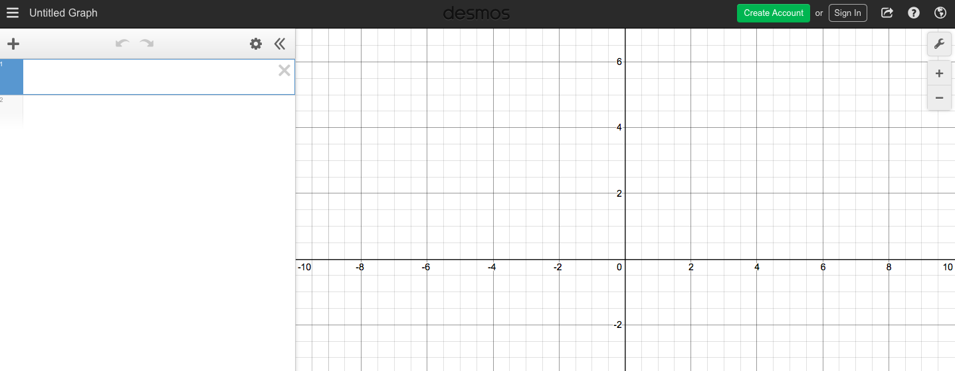

4. Under $f_{1}(x)$, enter the derivative of $f_{1}(x)=x^{2}-6x$ and label it as $f_{2}(x)$.

- You can see where $f_{2}(x)$ crosses the x-axis at (3,0). This is the critical point that we found earlier.

Let’s try some more:

- $f_{2}\left(x\right)=4x^{3}- 16x$

- $f_{2}\left(x\right)= x^{3}+{6x}^{2}+4$

